Prototype design

Due to time restraints it was decided to build a prototype before making a PCB and test the software. The prototype was all built from off the shelf parts, it did mean that testing and circuit design were done together and any problems could be fixed in software or hardware.

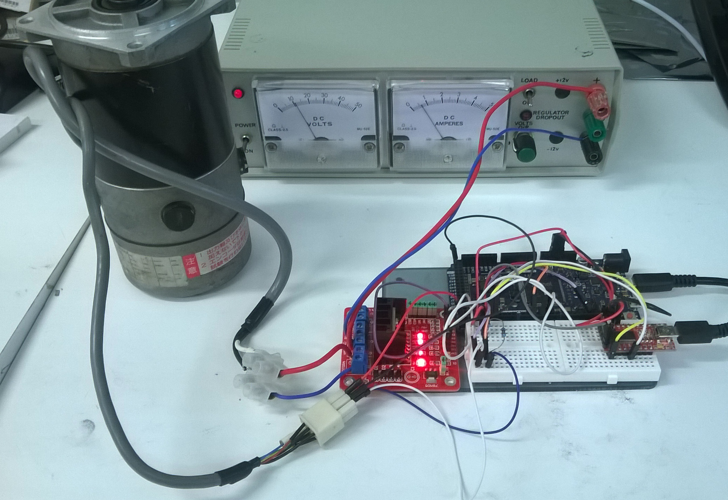

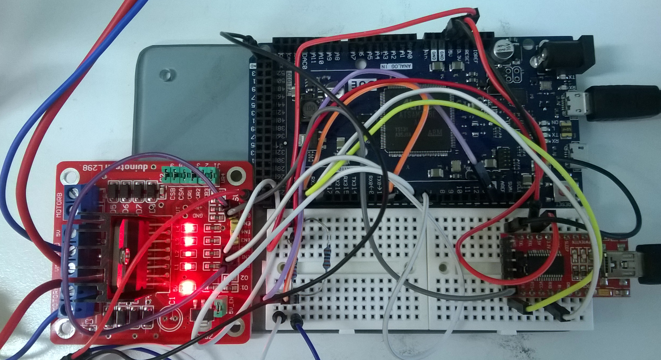

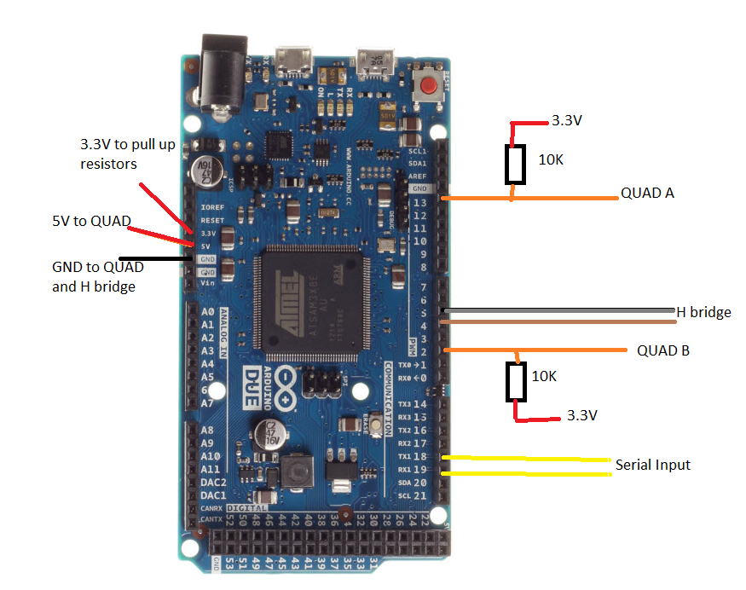

The prototyping was based on an Arduino (compatible) DUE board, a L298N H-Bridge motor shield, and a bench power supply. This is not identical to what will be installed in the pick and place machine, but provides a rough idea on how well the program will work. The L298N has a total power dissipation of 25 W (1). This is not enough to drive the motors as they require 300 W to run. The motors are very high torque, and are very hard to counteract the rotational force that the motor runs. If the rotational force has a load on it, then the H bridge is destroyed as there is way too much current for the L298 to handle. The same thing would happen on the 10A H-Bridge, but the power on the label on the motor is 300 W. This is maximum load current.